Battle Plan
Defeating Giants with Our Stones of Faith
On Fire Fit

You know the story. David & Goliath. Look down into your hands and imagine you are David holding small stones. Look up and notice your Giant standing before you. You already know the end of the story. One small stone of faith took down the Giant that had threatened David and everyone else in the vicinity.
Are we any different than David? We really aren’t. We have what we need: our God who is far more powerful than any earthly thing we face.
Then why do we toss our small stones of faith to the ground or just move them around in our hands instead of throwing them directly at the bull’s eye?
It all starts in our minds. When we look at our shortcomings and our long-standing history with this Giant, we talk ourselves right out of the fight. We might even retreat completely for periods of time instead of standing on the battle line ready to take some ground.
But that is all going to change starting now.
You already have the tiny stones of faith needed to take down the Giant in your life. You wouldn’t be here if you didn’t.
For though we walk in the flesh, we are not waging war according to the flesh. For the weapons of our warfare are not of the flesh but have divine power to destroy strongholds. We destroy arguments and every lofty opinion raised against the knowledge of God, and take every thought captive to obey Christ,
2 Corinthians 10:3-5
What we need to do is get our Battle Plan together and toe the line. What does it mean to “toe the line”?
We are getting our toes right up on that battle line and we are going to choose to obey and do what we know God has called us to do.
Obedience has some negative connotations that I’d like to dispel before we move on. Obedience is in no way our method for earning love or salvation from God. It is the grace He gives to us to act according to His will.
As I prayed today about this tension between grace and obedience I was immediately given words from the Lord. “No matter what, I will always love you and you are saved, but your abundant life will come through obedience.”
He doesn’t expect us to be perfect…..we know that. But, if we want to make some of these Giants in our lives fall, we have to step out in faith. We have to be obedient to what He asks and not cower in fear. We have to be willing to throw those tiny stones of faith with the assurance that it is the power behind those stones, our Mighty God that knocks down the Giant, not the size of the stone.
You will likely have different Giants in your life at different times. You are even likely to have several Giants all at once. The Battle Plan will be the same each time. We will be practicing this Battle Plan so that it becomes a part of you.

I’ve read many a motivational book and watched plenty of videos on self-improvement, but without Action, none of these things has changed me.
This Battle Plan is meant for ACTION and not just for reading and filing away. I pray that this time you will take the time to put some force behind what you read and understand in your head. This will be the life-changing stuff that you’ve needed. We will be creating some new habits. 90% of what we do comes from habit. If you change your habits, you will change your life. You are really good at habits! We just will work on habits that will take you in the direction that your current Giant is trying to keep you from! It is no accident that this Giant is in your life. The enemy does not want you to move in the direction that God is trying to take you.
Here is my definition of a Giant: anything that is keeping you from living the life God wants for you.
The Giant in your life will change from time to time and some may have been with you for many years. We also have opposing camps in this battle. One camp is led by God and what He says about you. The other camp is anything or anyone that deviates from His truth. That camp is made up of your destructive thinking, Satan and the World.
We have to make a choice which camp we are in. We have to decide which Commander in Chief we will follow.
Do the following exercise before we begin:
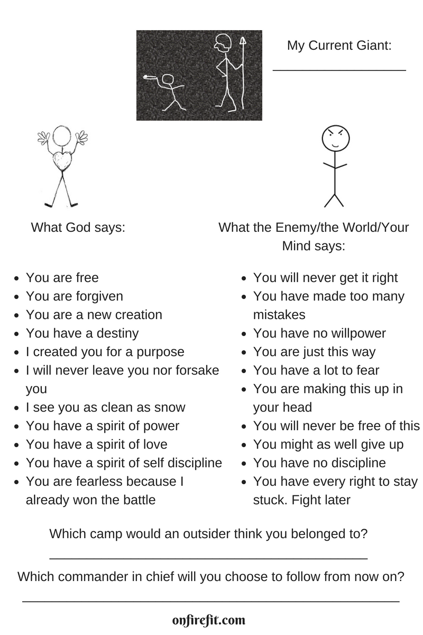
We will start this Battle Plan in Prayer. We will carry on this theme of praying at all times and on all occasions through the Acronym PRAY(ER). Watch as it unfolds.
Father God, we understand that the Giants we face in our lives are still smaller than You. We know of Your power, we know of Your love, and we know that You save us. Now, please help us to take on this spiritual battle with Action so that we finally see our Giants fall. Teach us Your way, O Lord. Lead us in a straight path (Psalm 27:11). You are our Commander in Chief and we choose to listen to you. In Jesus’ name, Amen.
Our acronym PRAY(ER) came to me one day while I sat in church:
Plan
Resolve
Anticipate
Yearn
(Eat
Real Food )
PRAY is for all the Battles in Life. Add the “ER” if your Battle is weight/health issues.
I will explain each of these as we go through our Battle Plan. The Last 2 have a smile because I truly believe that this is a huge part of our spiritual and mental battle. When we take care of our earthly bodies/His temple, we will feel better spiritually and mentally too. I don’t believe we can neglect one part of how God made us and still win the battle. For many of us, our Giant is Food and/or Drink. If you are one of the people that claim Health or Weight issues as your Giant, then the deeper discussion of this will be helpful. The “Eat Real Food” components will be explained in greater detail for my peeps that need it. For the rest of you, if you already do this, hooray! If you don’t Eat Read Food (unprocessed, God-made food), then start to prayerfully ask the Lord if this is an area you need to address. He will let you know when the time is right for you.
And now, let’s begin with the Battle Plan to Defeat Giants: PRAY(ER)
What you will need:
- Bible
- Journal
- Note cards
- Phone # of a fellow warrior or 2
- Pen or pencil and be ready to write!
What we will be doing in Battle:
- Offensive Tactics:
  - We will be on Active Duty at the same time as we are At Ease in the Lord
  - We will prepare for Attack through Praise and Thanks
  - We will put on our Armor through the Word and Prayer
  - We will be Alert for the ways that the enemy lies to us
  - We will develop Attitudes that believe in the power of Our God who is the weight behind the stone and not the stone itself
  - We will Arm ourselves with an Arsenal of Artillery
  - We will develop a strong base of Allies

- Defensive Tactics
  - We will learn how to Deflect incoming arrows
  - We will Decode messages
  - We will practice through Drills
  - We will Defend what we know that God has said
  - We will live in a state of Determination

Plan
David had a plan when he decided to fight the Giant. He knew he needed to defend God’s name. King Saul thought David needed his heavy armor to protect him, but when David put it on, he couldn’t move about swiftly as he had done as a shepherd out in the fields protecting the sheep from their giants! David didn’t follow a plan that Saul thought would work, he had a plan that was God-designed. We will do the same. God has a specific plan for your life. We need to be ready to defeat anything that tries to stand in the way of that plan, through the power of His Word and prayer.
It’s been said that failing to plan is planning to fail.
Every soldier is trained and plans ahead of time. The plan comes from the Commander in Chief. He decides the best way to fight and the soldiers follow the orders. The plan is the best way to execute the drills that are practiced and how to join together with their allies to push the enemy away and destroy it. Without a plan, the soldier would not have direction when the attack comes.
It is no secret that soldiers learn discipline and create habits as soon as they join the military. Habits keep them from having to decide moment to moment what to do. They are freed up mentally when they create habits. They also learn discipline and they don’t choose when they feel like being disciplined and when they don’t.
We get our plan by standing connected to the Vine.
Apart from Me you can do nothing. John 15:5
Our plan will be to practice drills (habits), develop discipline and learn tactics to recognize the attacks of the enemy (our Giant) and gain ground. We will use the Sword of the Spirit, the power of the tongue and the renewing of our minds to take back what has been stolen from us!
Resolve
To make our way, we must have firm resolve, persistence, tenacity. We must gear ourselves to work hard all the way. We can never let up.~ Ralph Bunche
We have to get this firmly in our minds: resolve means we won’t be following flaky feelings.
Soldiers don’t make a lot of independent decisions. They learn the way to live and fight and they stick to that with firm resolve. We have to do the same. We cannot let the enemy decide whether we will follow through with the plan God has laid out for us. We must have a firm resolve and a never give up attitude. Another word for this is Grit. And, yes, you can develop Grit if you don’t have it already!
We decide we are choosing God’s way and not our own way or what the world says is the way. We have to plant this firmly in our minds or else the first arrow that comes at us will cause us to give up. This does not mean we won’t make mistakes. It means we are resolved to continue to get back up when we get hit occasionally, instead of retreating entirely!
Anticipate
One of the main things that I see causing people to give up a fight or get really off track (myself included!) is not anticipating the arrows that will most definitely come at us when we have planned and resolved to go in God’s direction. The enemy is not going to roll out the red carpet for us to get on God’s plan for success! So, when the first arrow comes our way (illness, busy life, family problems, excessive stress, etc.), if we have not anticipated it, we will fall back. We must start to anticipate those things that will be coming and then plan our response.
We will be learning how to do this, by the power of God and His Word and PRAYER.
Yearn
I chose this word because everything changed when I began to yearn for God and what He wants for my life.
When I didn’t yearn for Him and what He wants, I got very caught up in worldly thinking.
Soldiers yearn for discipline and this creates the backbone of success.
During the American Revolution, the relative discipline of an army was often far more important than its strength. “Discipline is the soul of an army. It makes small numbers formidable; procures success to the weak, and esteem to all,” said George Washington.
“There is something good in men that really yearn for discipline”. -Vince Lombardi
Is it possible to yearn for discipline? It seems like discipline is something that you just force yourself through, right? Actually, wrong!
“True freedom is impossible without a mind made free by discipline.” ― Mortimer J. Adler
It is within the boundaries God has given us that we actually experience freedom. When we step outside His boundaries, we end up in a mess. Staying within His boundaries requires discipline and ultimately produces freedom!
As we learn to Yearn for what God wants, we will experience freedom.
I will walk about in freedom, for I have sought out your precepts. Psalm 119:45
Read the same verse from The Message:
And I'll stride freely through wide open spaces as I look for your truth and your wisdom.
Who doesn’t want to stride freely through wide open spaces? I’m signing up for that!
Let’s set out to Yearn for Him and His will!
Eat Real food
On Fire Fit came about because of my long history of being intrigued by our bodies and how God made us. Not only that, but I have noticed in my own life as well as others that when we don’t feel good physically, we tend to get out of sorts mentally and spiritually. Teaching patients and clients how to eat in a healthy way has been a passion of mine for well over 20 years so it comes as no surprise that “Eat Real food” would be included in the Battle Plan that God put on my heart!
Or do you not know that your body is a temple of the Holy Spirit within you, whom you have from God? You are not your own, for you were bought with a price. So glorify God in your body. 1 Corinthians 6:19-20
It is part of our job to take care of the earthly body we’ve been given and not just our spirit and soul and mind.
God gave us real food to eat. Eating food the way He gave it to us and eliminating the processed stuff will start to change our bodies and this in turn will give us the ability to fight like well-trained soldiers!
Another area that can become a problem due to its tendency to distract us is alcohol. I don’t believe that everyone needs to abstain but I do believe that this verse makes a whole lot of sense when we are fighting a giant. If we are not sober-minded, we are much more likely to fall into the traps laid out for us.
Be sober-minded; be watchful. Your adversary the devil prowls around like a roaring lion, seeking someone to devour. 1 Peter 5:8
So, you decide what you will do with this section. Some people who already identified their Giant as being Food/Drink/Weight issues/Health will be delving into my On Fire Battle Plan for Nutrition. If you choose this, you will join me in another section. Otherwise, I encourage you to honor God with your body and be sober-minded so that you can face your Giant head on!

Battle Plan
- Read the weekly material
- Journal
- Make notecards of your verse or phrase that you will say out loud
- Come together to share if you are comfortable with your Allies!

On Fire Fit
Jen Colon
onfirefit@gmail.com
YouTube: http://www.youtube.com/c/OnFireFit
Facebook: https://www.facebook.com/jenonfirefit/
©OnFireFit, 2018

